### **Web Application 1: *Your Wish is My Command Injection***

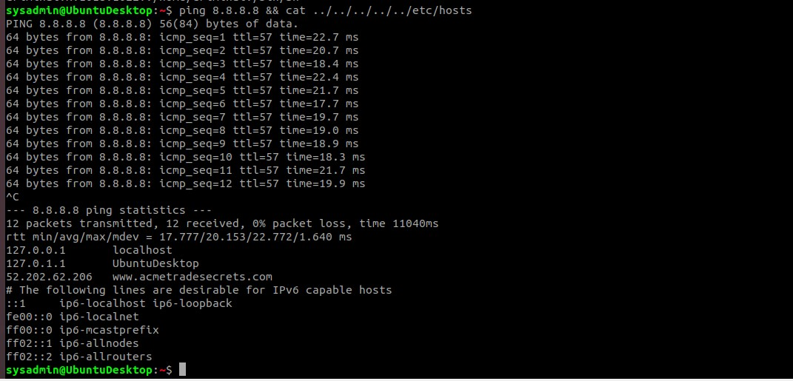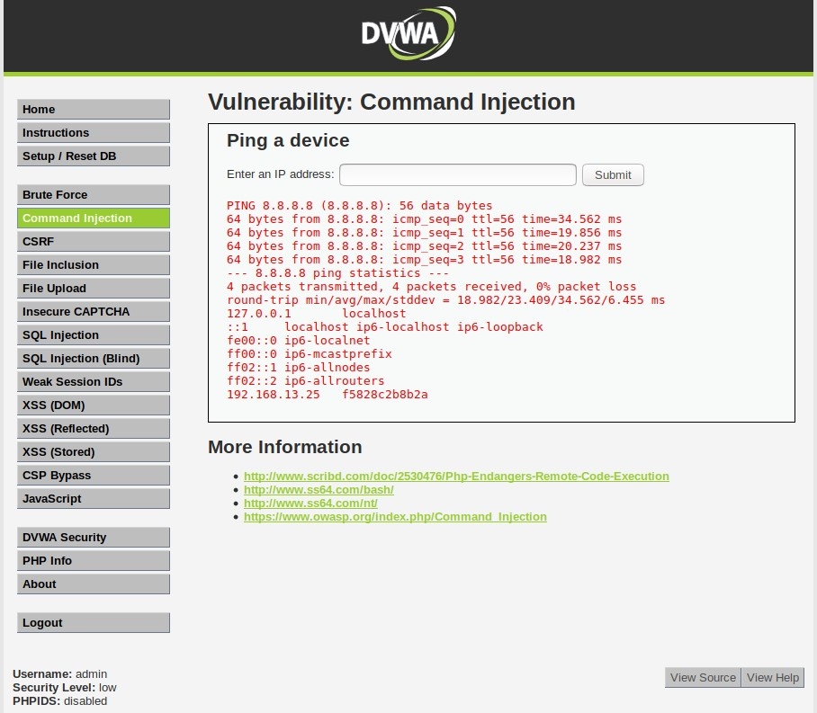

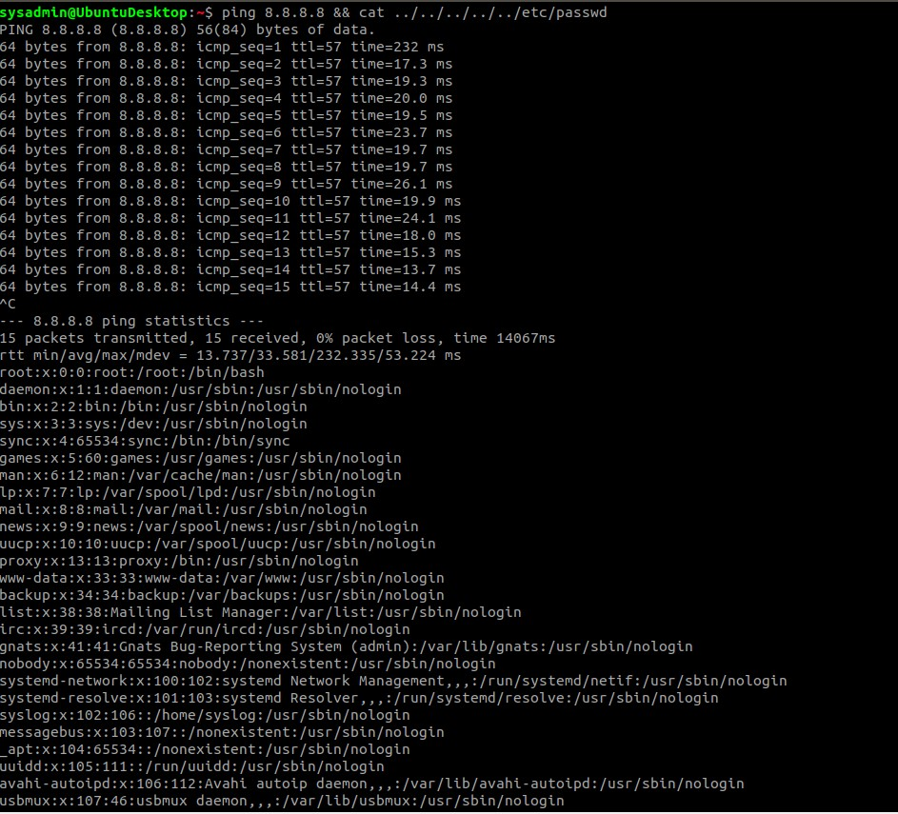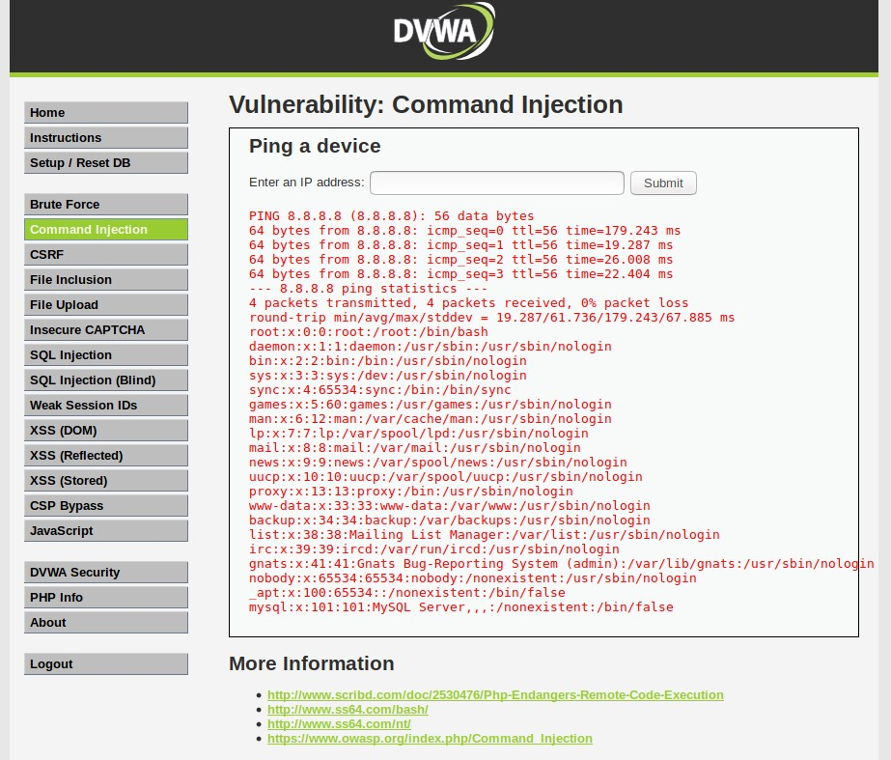

RECOMMENDED MITIGATION STRATEGIES:

* In order to effectively reduce the number of users who have access to confidential files and places where confidential files are stored, implement Security Permissions/Restricted Permissions.

### **Web Application 2: *A Brute Force to Be Reckoned With***

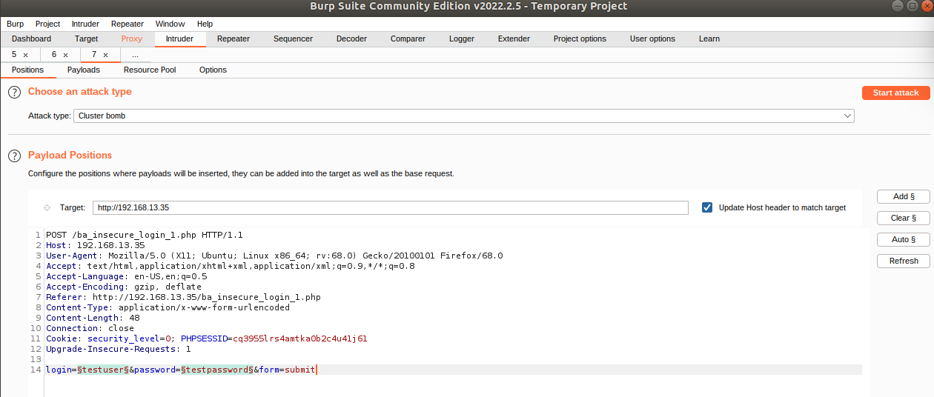

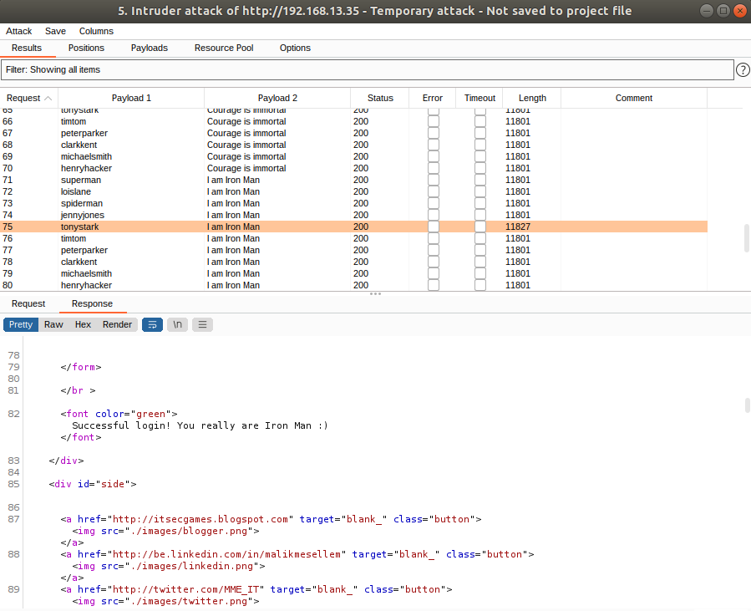

RECOMMENDED MITIGATION STRATEGIES:

* Having regulations for usernames and passwords in order to make them more complex will decrease the likelihood of a successful attack; for example, requiring passwords to have at least one uppercase letter, at least one number, at least one special digit, and be at least 8 digits long.
* Locking out an account after a certain number of failed attempts.
* Having mandatory two-factor authentication for users when they log into their accounts.

### **Web Application 3: *Where's the BeEF?***

PRETTY THEFT

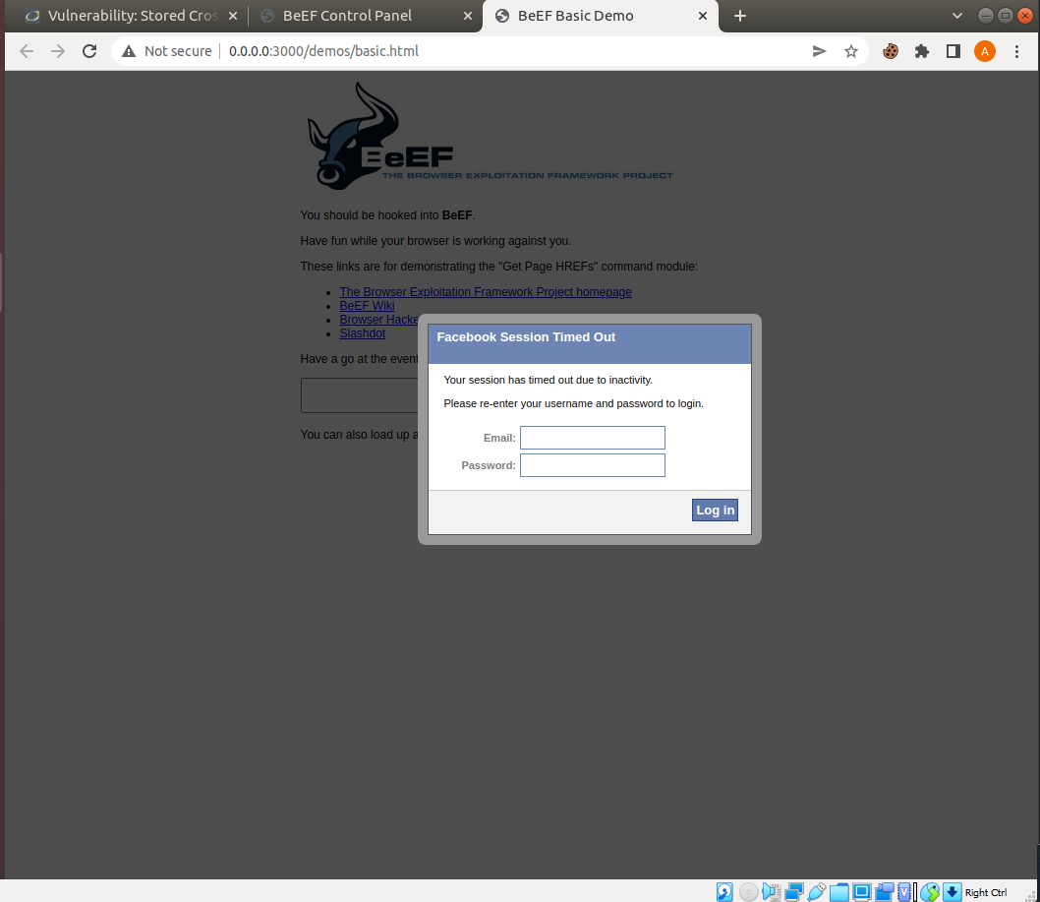

FAKE NOTIFICATION BAR

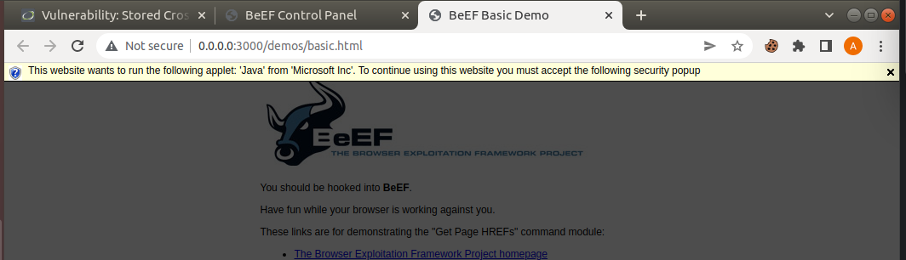

GET GEOLOCATION (THIRD PARTY)

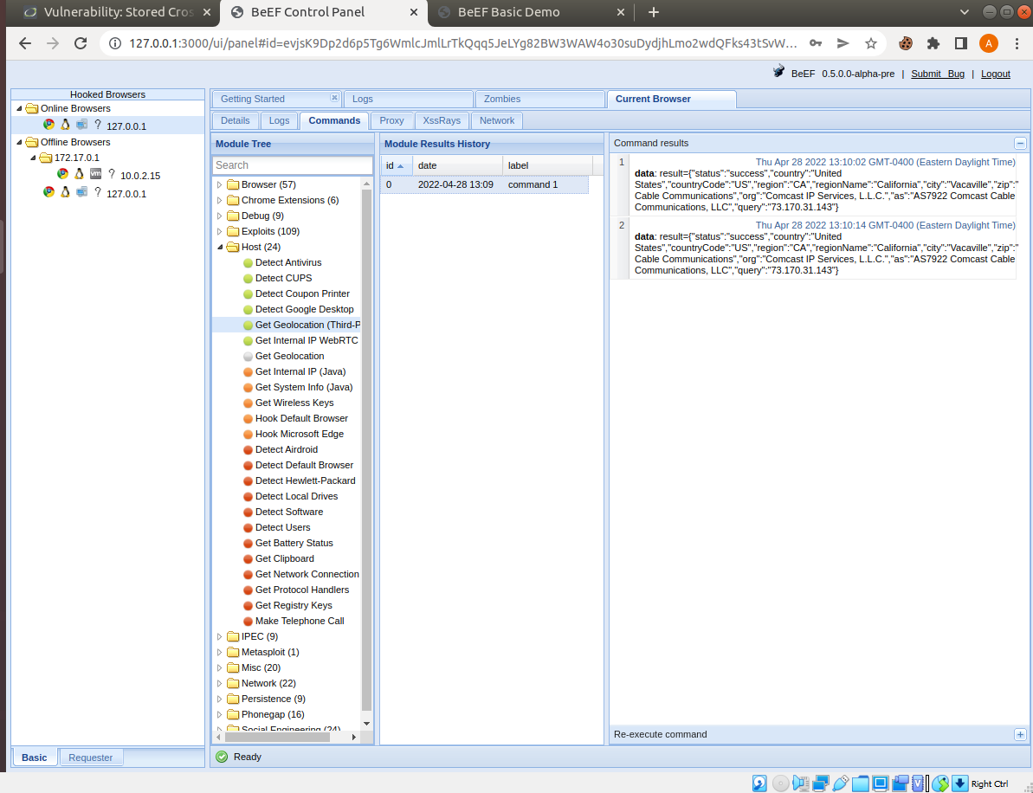

RECOMMENDED MITIGATION STRATEGIES:

* According to an article on techtarget.com, one way to mitigate web browser vulnerability attacks is to consider which browser you are using. For example, “Internet Explorer may be compatible with legacy applications that don't play well with other browsers, but it also tends to have far more vulnerabilities, and more known unpatched vulnerabilities, than others” (Chmielasrki, 2010).
* Keep up to date on your browser’s privacy settings - for example, Microsoft/Internet Explorer has tracking protection, which “helps prevent information about your browsing from being sent to third-party content providers on sites you visit” (<https://support.microsoft.com/en-us/windows/change-security-and-privacy-settings-for-internet-explorer-11-9528b011-664c-b771-d757-43a2b78b2afe>).

RESOURCES:

Chmielarski, Tom. “How to Avoid Attacks That Exploit a Web Browser Vulnerability.” SearchSecurity, TechTarget, 30 July 2010, https://www.techtarget.com/searchsecurity/tip/How-to-avoid-attacks-that-exploit-a-Web-browser-vulnerability.

“Microsoft.” Microsoft Support, https://support.microsoft.com/en-us/windows/change-security-and-privacy-settings-for-internet-explorer-11-9528b011-664c-b771-d757-43a2b78b2afe.

GITHUB CLASS ACTIVITIES & STUDENT GUIDE, WEEK 15